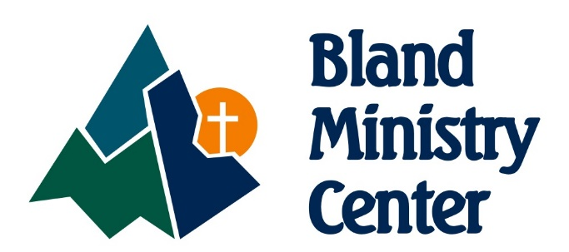
RACE T-SHIRT
SPONSOR FORM
2018

This fall, Bland Ministry Center will host a family event including a “Half K for Kids,” a tongue-in-cheek riff off of a traditional 5K race, no running required, to benefit and raise awareness for the children’s programs offered throughout the year. There will also be an “Overachiever 5K” and food truck round-up open to the public. All proceeds raised will go towards supporting Summer Feeding, Back to the Books school supply program, and Santa’s Workshop for local children. This event coincides with National Family Fitness Day and Good Neighbor Day: the perfect excuses to get out and move in support of some precious kids. Please consider donating towards these programs where your gift can feed children, equip them with the tools they need to learn, and bring them joy on Christmas morning. We would love to express our gratitude by representing your business or organization on the back of the t-shirts that will be distributed to all Half and 5K participants.
Sponsor Levels and Prices:
- 5” logo size - $500
- 3” logo size - $200
your name here your name here your name here your name here your name here your name here
- 2” logo size - $100
- text - $50
Company Name: _________________________________
Contact Name: __________________________________
Address: _______________________________________
_______________________________________________
Phone Number: __________________________________
Email Address: ___________________________________
If choosing the logo option, please send a high-resolution logo image to skeene@blandministrycenter.org
Please return form and artwork no later than September 1, 2018
If you need assistance or have questions, please call Susan (276)688-4701

Checks should be made payable to Bland Ministry Center:
PO Box 211
Bland, VA 24315

